### OCP card FRU programming

Requirement:

1. APT13181 main board with AMI BMC firmware.
2. Linux Host running on APT13181.
3. OCP Card and FRU EEPROM write protect disabled.
4. Frugen tool and FRU information json file.

Step:

1. Plug the OCP card to slot 0

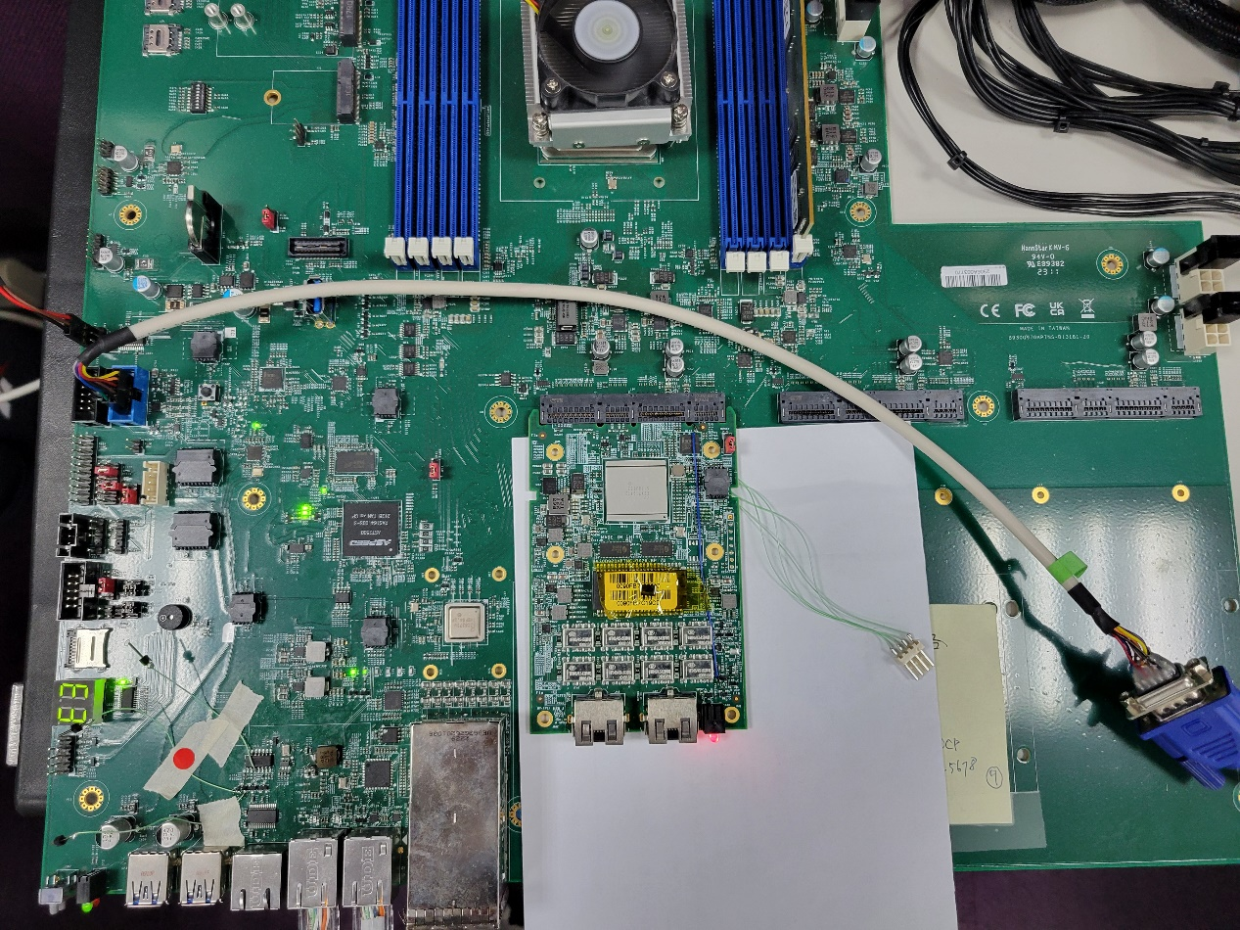

1. Power on the main board.
2. When BMC ready, then power on the host server.
3. Copy frugen tool and json file to host server.
4. open the terminal and covert FRU info. Json file to binary file.

./frugen -j -z pnc-ob2r-g10-fru.json pnc-ob2r-g10-fru.bin

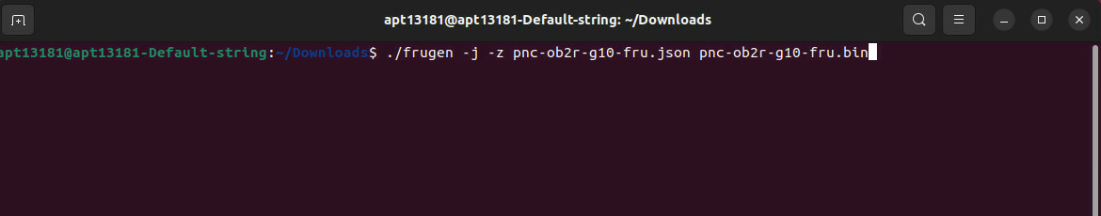

1. Read FRU information:

Command for slot 0: sudo ipmitool fru print 0x01

Command for sloe 1: sudo ipmitool fru print 0x02

If OCP card exist and eeprom content is empty. The reading info is:

“unknow FRU header version 0xff”, if card is not exist the info is:

“Device not present (Unknown (0x81))

1. Writing FRU information

Command: sudo ipmitool fru write 0x01 pnc-ob2r-g10-fru.bin

1. Read FRU information

The ipmitool cannot recognize the OCP FRU multi-record information

